Customer Relationship Management Web Application

* Index.jsp

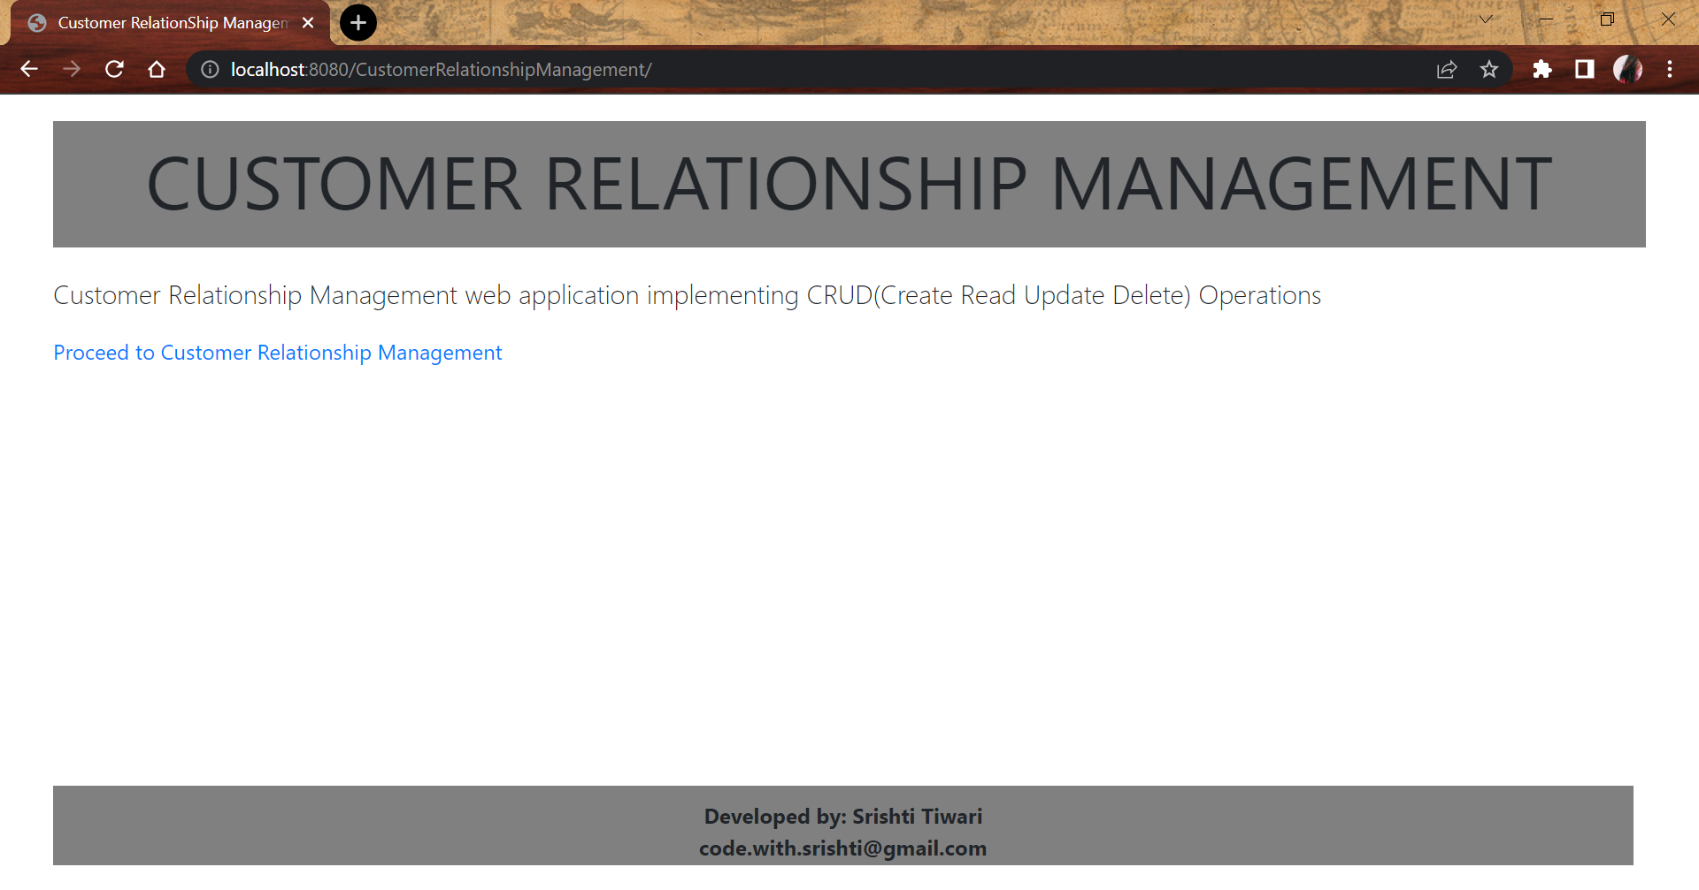

* On clicking on “Proceed to Customer Relationship Management” hyperlink

Form listing the entries from the customers table is displayed along with the **Add Customer** button to add a new customer

For each line item in the table, user has the capability to update/delete the record.

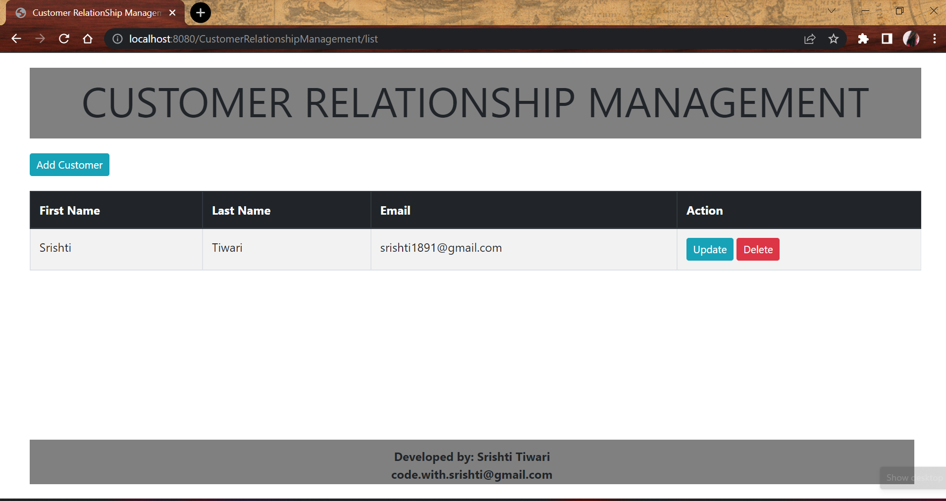

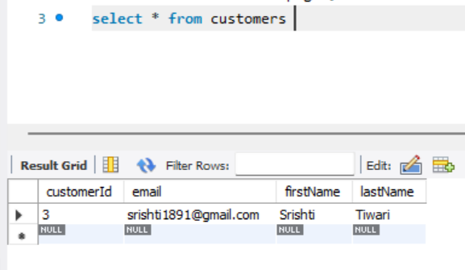

* Upon clicking Add Customer button, user get redirected to add customer form

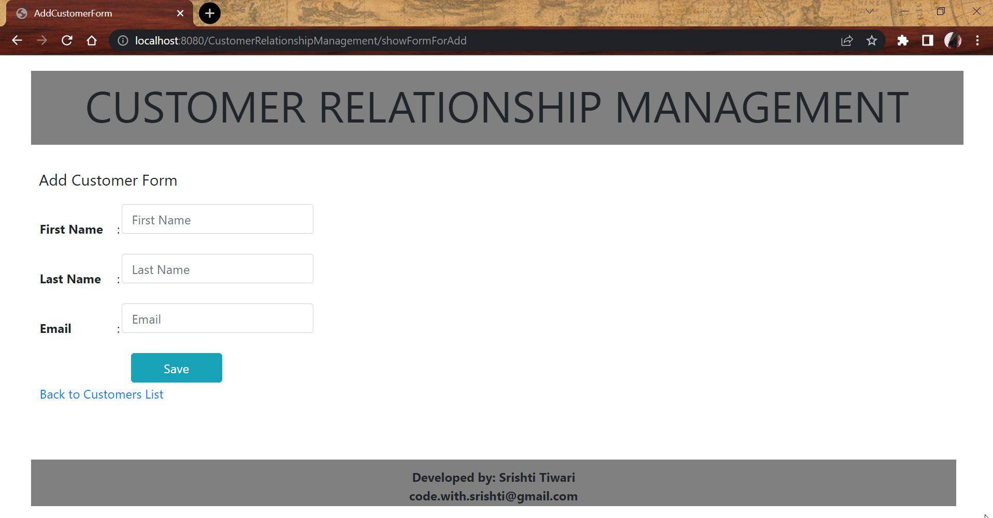

All the 3 fields are marked as required so as the avoid blank entries from getting added.

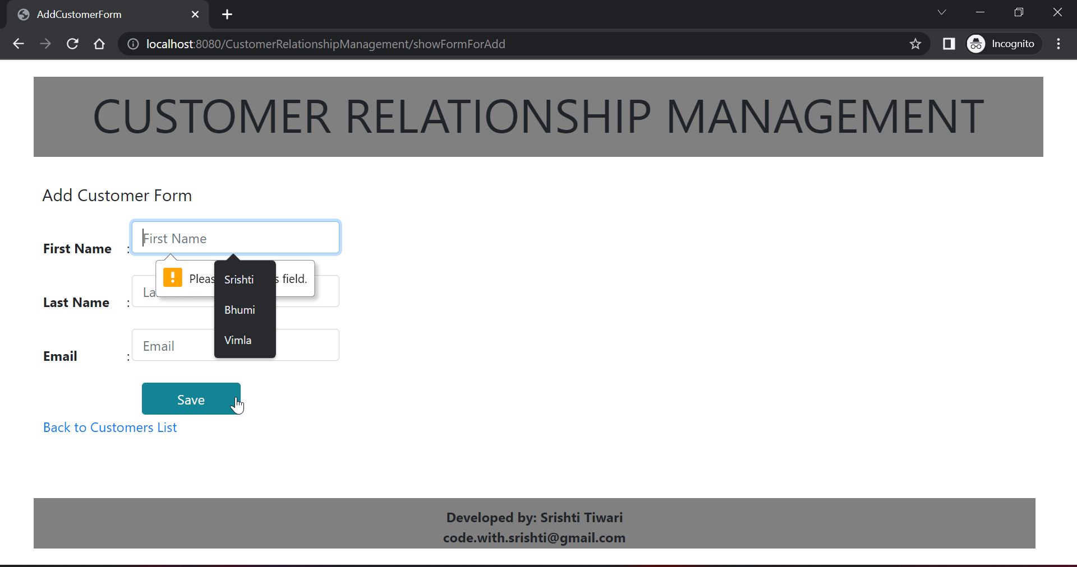

* User fills in the required inputs in the form to add a new customer:

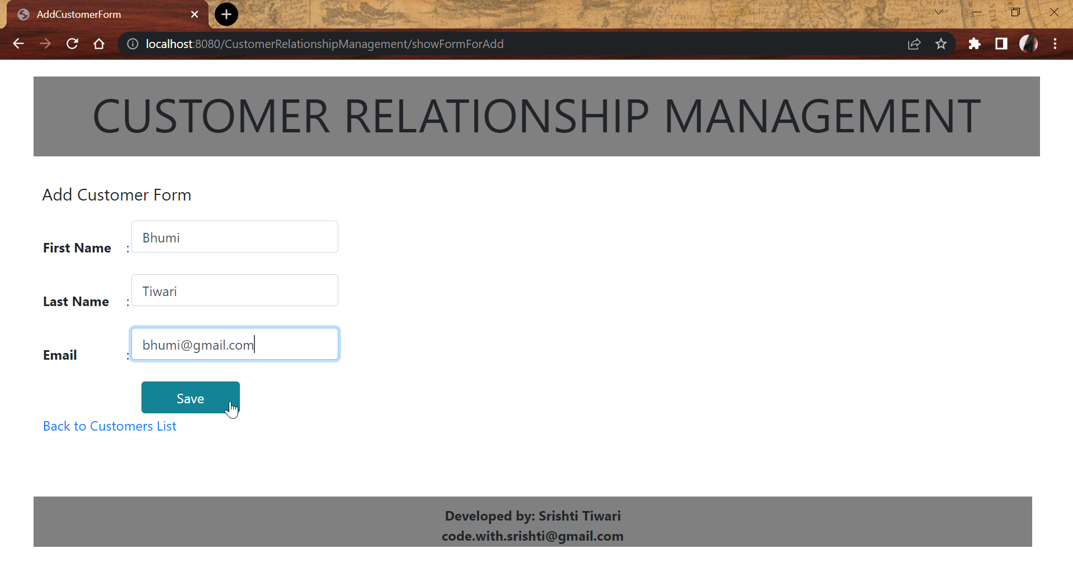

* After filling the details and clicking save, the new records gets added in the table and displays on the web page:

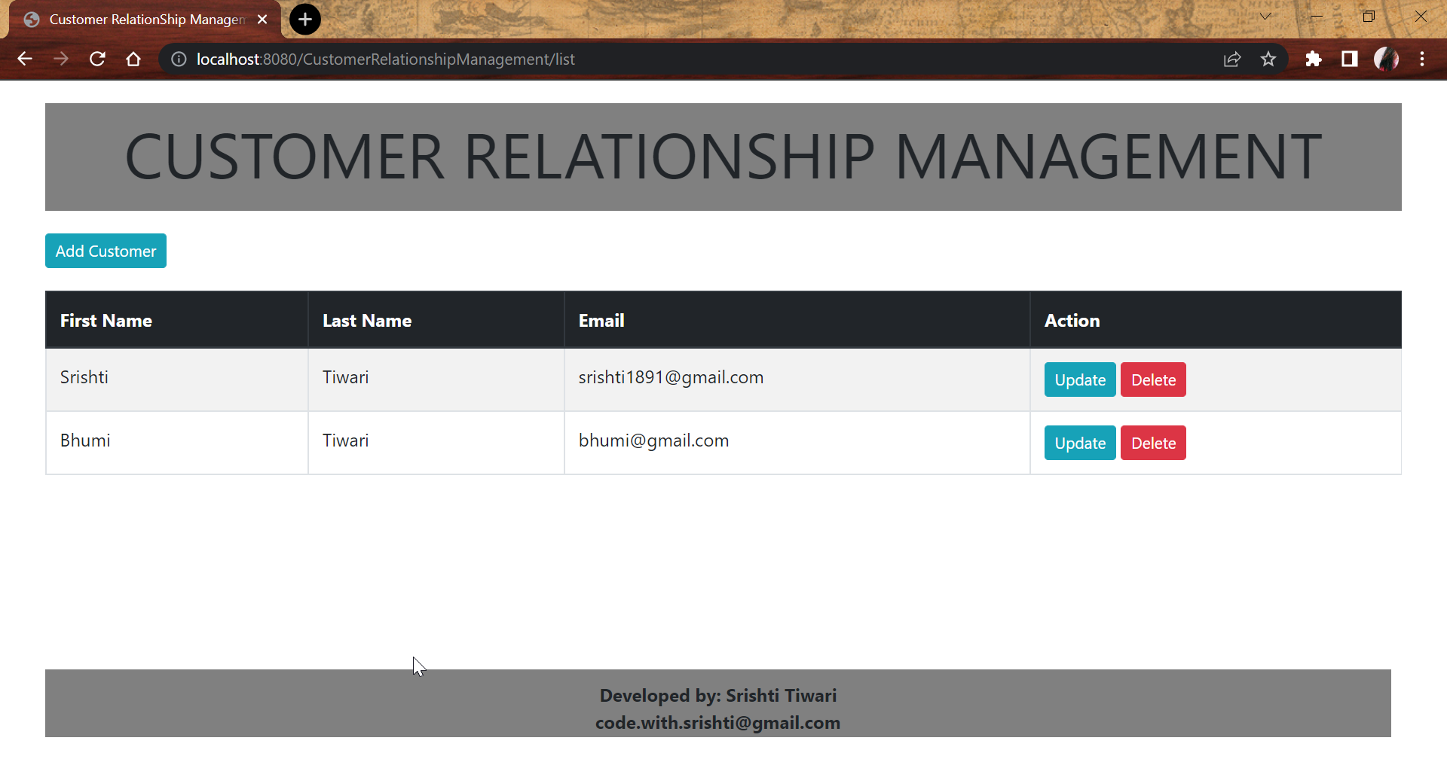

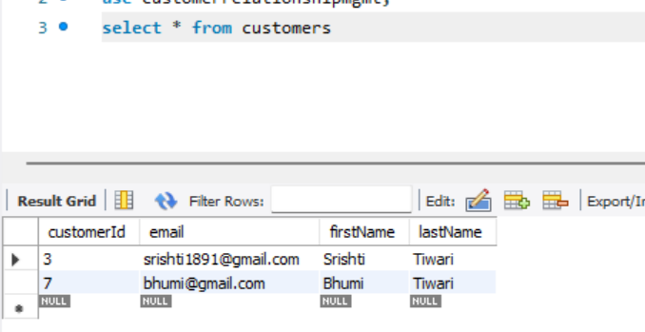

* If user decides to delete a customer record, they get prompted to give confirmation

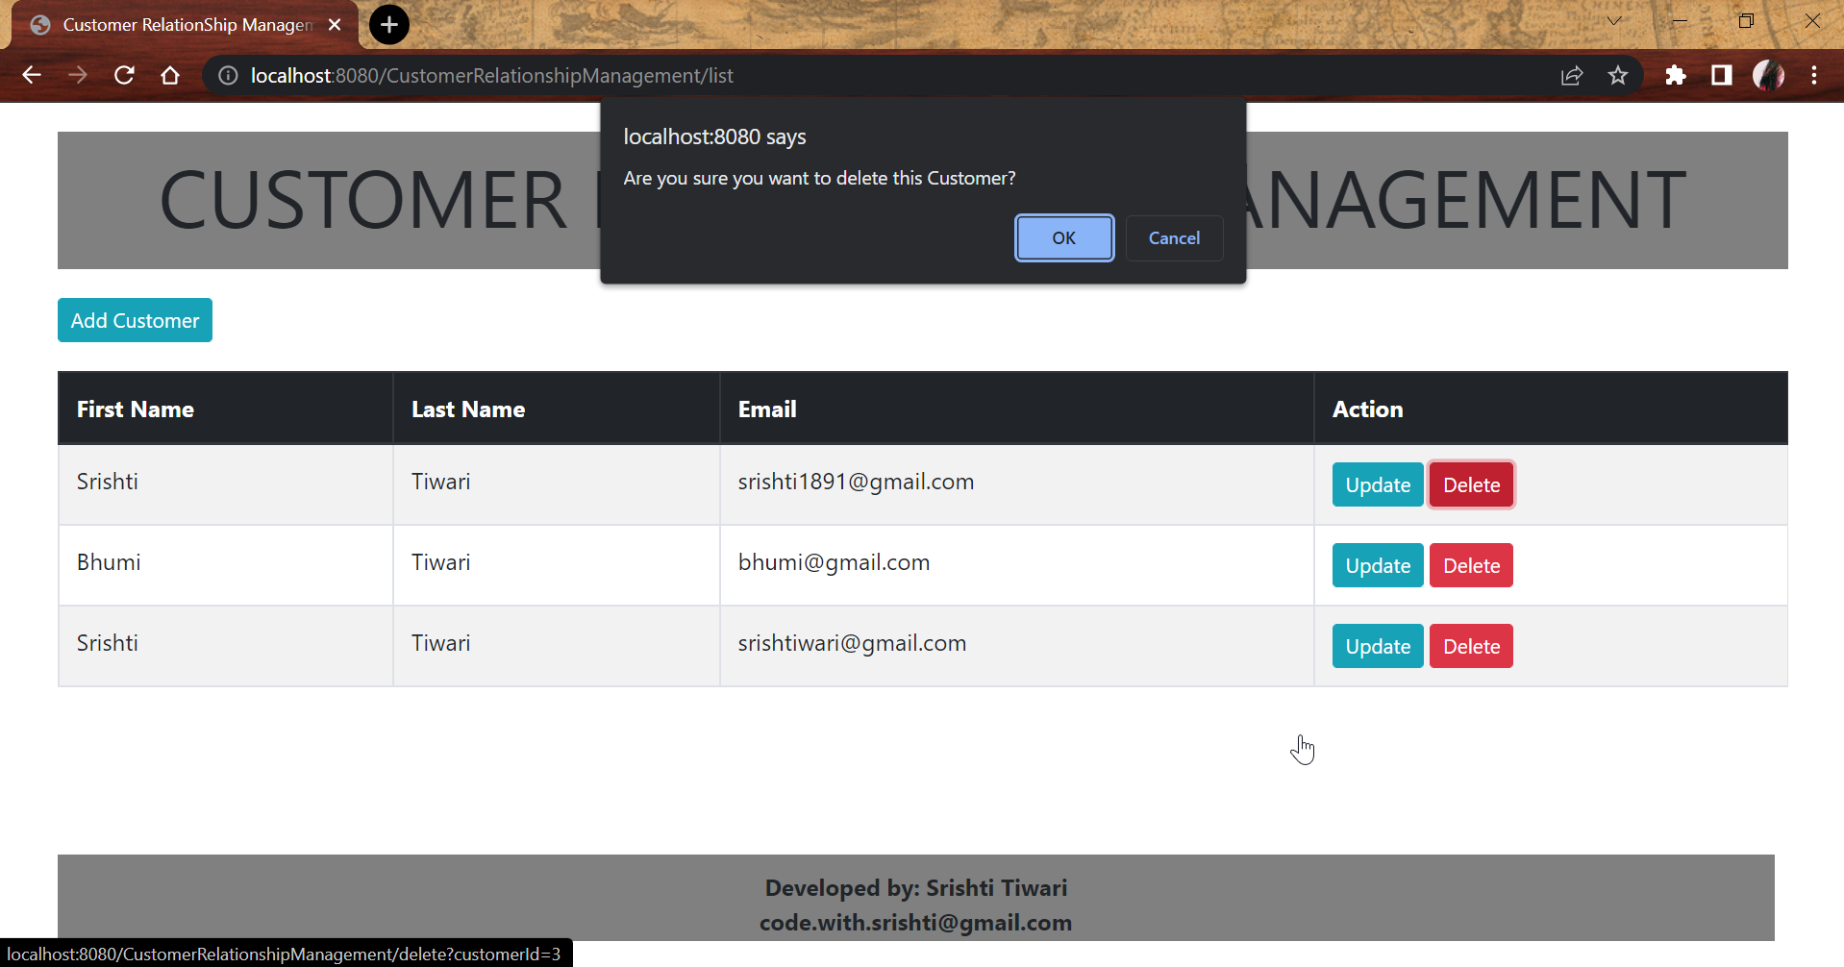

* After the confirmation is received, the data gets deleted from database table as well as doesn’t display on the web application:

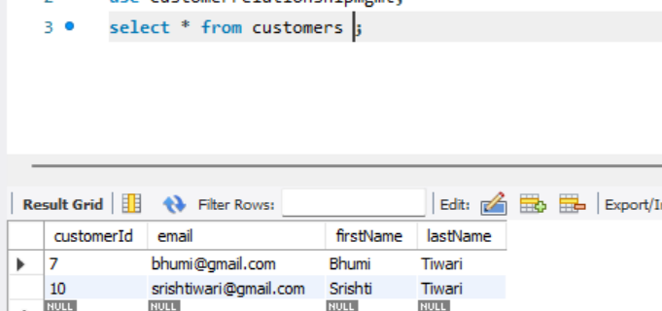

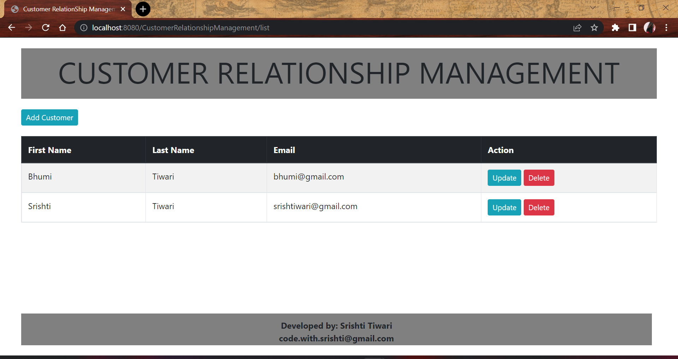

* User can decide to update the entries from the form to update required information for the customer records:

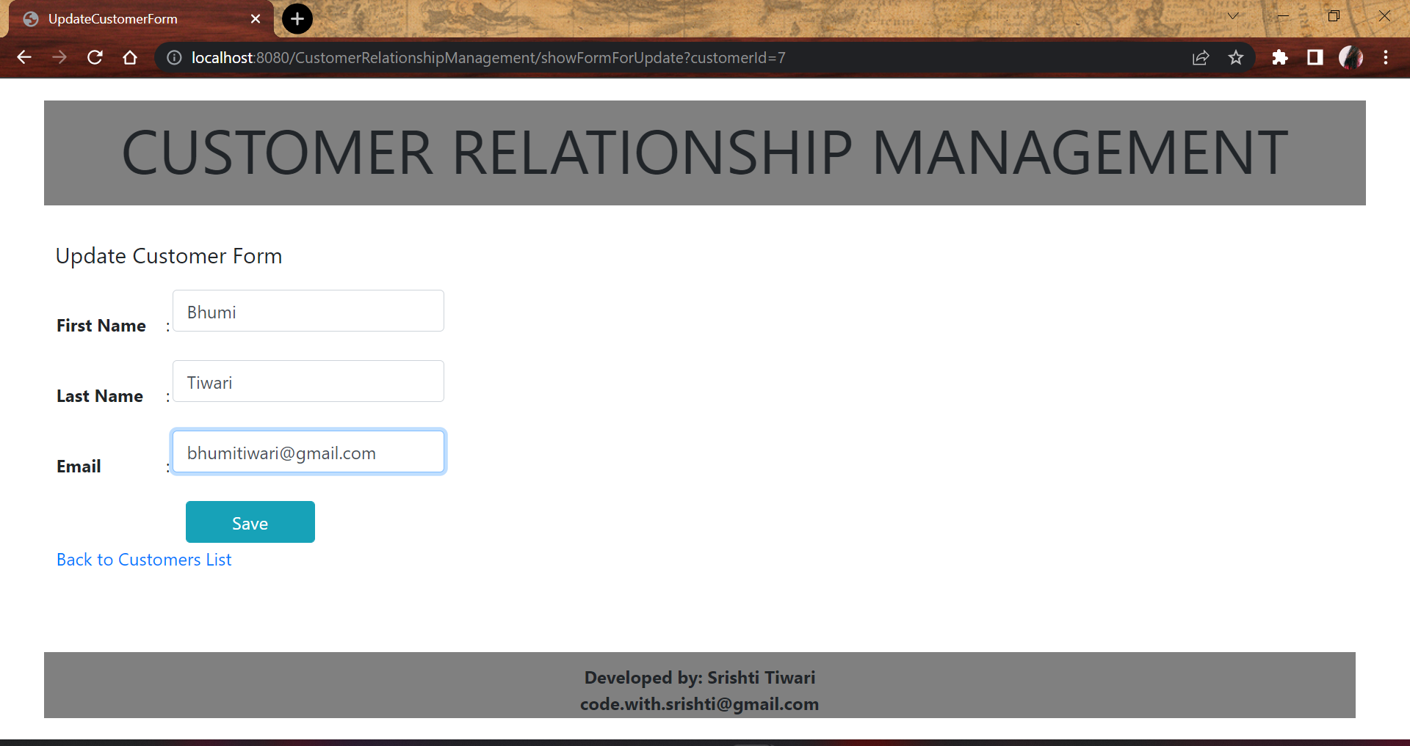

* Once the information is updated, user clicks save to update the record in the database table and display the same in the web application: 